Group Case Analysis and Presentation Project-2018

The case analysis and presentation project will be held on Nov 2nd, 2018(Friday afternoon), from 13:30pm to 15:10pm, in classroom F2204. It is a great chance for students to work creatively.
The class would be divided into 4 groups before preparation, and each group should select only one case to discussion.
Group 1: Case Report One
Group 2: Case Report Two
Group 3: Case Report Three
Group 4: Case Report Four

Instructions:
- Each group need around 20mins to present your case analysis according to those questions in class;
- Group members are responsible for answering several questions from other groups for approximately 5 minutes;
- PPT may be prepared before presentation;
- Diverse forms presentation are encouraged such as PPT presentation, Role play, video documentary….

Case Study 1: Abortion or continuing pregnancy
A 28-year-old woman who is 10 weeks pregnant presents to the obstetrics clinic for prenatal care. She has a history of treatment for syphilis 7 years previously. The results of serologic tests for syphilis are as follows: nontreponemal test, TRUST (toluidine red unheated serum test), reactive (Fig.1); treponemal test (TP-PA) was not detected.
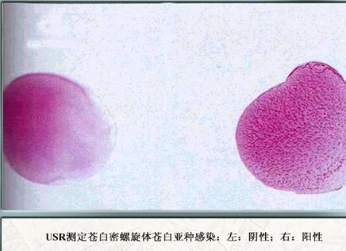
Patient sample
Negative control

Fig.1 TRUST result from the patient

Q1. What type of pathogen causes Syphilis and what are the characteristics (Morphology, Culture character, etc.) of the pathogen?

Q2. What is TRUST (toluidine red unheated serum test)?

Q3. What is treponemal test (TP-PA)?

Q4. What is the different between RPR test and treponemal test?

Q5. How do people get syphilis? (Bacteriology, transmission)?

Q6. In this case report, the woman is in which stages of syphilis? Does she have an abortion or continue her pregnancy?

Case Study 2: The woman has had 15 male sex partners
A 25-year-old woman is referred to the sexually transmitted diseases clinical because of contact with a male partner with gonorrhea. The woman has had 15 male sex partners since becoming sexually active. The likelihood that she also has genital Mycoplasma hominis infection is very high (about 90%).

Q1. What are the characteristics of Mycoplasma ?

Q2. In humans, four species of Mycoplasma are of primary importance: Mycoplasma pneumonia, Mycoplasma hominis, Ureaplasma urealyticum and Mycoplasma genitalium. List those diseases caused by these four microbes.

Q3. How to treat Mycoplasma infections?

Q4. Why the rate of co-infection with Mycoplasma hominis and Nesseriea gonorrhea is so high?

Case Study 3: Adolescent troubles
An adolescent female came to the clinic because of a new and unusual vaginal discharge. She had recently become sexually active and had two new partners during the previous month. On pelvic examination a purulent discharge was seen at the opening of her endocervical canal.
Q1. Which of the following statements about this case is most correct?
  - A serologic test for syphilis is not indicated because her symptoms are not those syphilis
  - A Gram stain of her endocervical specimen would show Chlamydia trachomatis inside polymorph nuclear cells
  - The differential diagnosis includes infection with Neisseria gonorrhoeae or Chlamydia trachomatis
  - The endocervica specimen should be analyzed for herps simplex
  - Initial treatment is with ampicilllin

Q2. What is the reason of your answer?

Q3. What is the special reproductive cycle of Chlamydia?

Q4. Describe the characteristics of Chlamydia.

Q5. Describe the pathogenesis and pathology of Chlamydia.

Case Study 4: After a tick bite
A middle-aged sportsman, resident of Oklahoma, took a hike through a rural wooded and brushy area near his home. The following morning he noticed and removed a large (>1cm) tick from his upper arm. About 1 week later, he experienced a gradual onset of fever and malaise. He now seeks medical attention because he is concerned about a possible infection transmitted by the tick. Doctors diagnosed that the patient gets Rocky Mountain spotted fever acquired from a tick.

Q1. What are the properties of Rickettsia?

Q2. Describe the serologic tests being used to diagnose rickettsial diseases.

Q3. Summarize the Epidemiology and Season Occurrence of Rickettsial infections.

