The effects of Social contextual information on female mating preferences and mating strategy

Abstract: This study focuses on the effects that social contextual information has on female mating preferences and mating strategy. The study adapted the paradigm of Hill and Buss (2008) by adding the mating strategy as the dependent variables and tested the mating preferences in a more implicit way. Results show that the presence of other women, which serves as social contextual information in this study, can enhance female’s mating preferences towards the potential mates and render them to take an active mating strategy.
Key words: Mating preferences mating strategy Social contextual information

1. Introduction and Literature Review
Historically, empirical research on mate choice has focused on individuals’ preferences in the absence of social contextual information. An increasing number of researchers however in the biological and social sciences have begun to recognize the important role context plays in cross-sex desirability judgments (e.g. Dugatkin, 1992; Graziano, Jensen-Campbell, Shebilske,& Lundgren, 1993; Hill & Ryan, 2006; Jones, DeBruine,Little, Burriss, & Feinberg, 2007; Schlupp, Marler, &Ryan, 1994; Sigall & Landy, 1973). From the perspective of evolutionary psychology, women seem to be more selective than men when they choose their mates as they will invest more than men if they become pregnant. Therefore, women tend to choose their mates who are resourceful, prospective and willing to take the responsibility to bring up the child (Trivers, 1972). In contrast instead of looking for someone who is resourceful and prospective, men tend to choose their mates who are young and beautiful （Buss, 2003; Buss, Shackelford, Kirkpatrick, &Larsen, 2001; Kenrick, Groth, Trost, & Sadalla, 1993）. Since social status cannot be directly observed from the appearance of men, women tend to use social contextual information to judge their potential mates.

Researchers has found a mate choice copying effect when they added the social contextual information to the researches of mating. Mate choice copying is a non-independent mate choice strategy that is said to occur when the likelihood that one individual (the "observer" or "focal individual") will mate with a particular individual (the "target") increases or decreases based upon observing a sexual interaction between the "target" and another individual (Dugatkin, 1992, 2000). This effect has first been discovered in some animals such as fish and birds (Dugatkin & Godin, 1993；White & Galef, 1999), and later in human beings, especially in women (Eva &Wood, 2006; Jones, 2007; Hill & Buss 2008). The typical paradigm of mate choice copying can be broken down into three steps: 1) An initial preference is established by observing an individual's choice when being exposed to potential mates for the first time; 2) This first individual is then allowed to observe another individual making a choice towards the potential mates; 3) The first individual is then allowed to make a second choice. If the preference that the participants make has been changed after they observe another individual’s choice, the researchers can make the conclusion that the participants have been affected by the choice of another individual, hence they underwent the mate choice copying effect. Using this paradigm, scholars have found many factors that affect the mate choice copying effect, such as the attractiveness of “another individual”（Yorzinski&Platt ,2010；Little,2008; Waynforth,2007) , the attractiveness of the potential mates（Johansson &Uller,2002), the age and sexual experiences of the participants (Waynforth,2007). Furthermore Hill and Buss (2008) have used another paradigm to investigate this effect. They divided the 478 heterosexual women into three groups and exposed them to three kinds of pictures. In the first picture, each target person is depicted sitting alone at a table in a university courtyard. In the second picture, each target is sitting among 4 college-aged individuals who are of the targets’ opposite sex. In the third picture, each target is pictured seated among 4 college-aged members of the target’s same sex in the same university courtyard setting. The participants were asked to rate the desirability of the target from five aspects, for example, the attractiveness of the targets, whether the target can meet the standards of ideal mates of the participants etc. Hill and Buss find that women will perceive the men who are depicted with 4 women as most desirable. They claim that it is because the participants are affected by the social contextual information that they perceive the target depicted with 4 women most desirable. In their view, when a man is depicted with 4 other women, it implicitly indicates that these 4 women may be interested in this man and thus provides valuable information about the man’s quality. Besides, in contrast to the visa photos used in the typical paradigm, the pictures in this paradigm are taken in daily life, thus can increase the ecological validity of the experiment.

As for the reasons why women are more easily affected by the social contextual information than men, researcher believes that it is because men and women have different mating preferences. As for women, they tend to prefer men who are resourceful and prospective, however, the information that indicates the social status and resources of men cannot be directly observed through the appearance of men. Research also suggests that individuals attempting to make sense of such ambiguous social stimuli tend to rely on simple heuristics that incorporate available contextual information to increase the accuracy of their judgments (e.g., Gigerenzer & Todd, 1999; Tversky & Kahneman, 1974). Therefore the presence of other women who appear to be interested in a man may provide valuable information about that man’s quality and offer a more accurate indication of his real mate value than any one woman could make by herself (Graziano et al., 1993), However, as for men, they tend to prefer women who are young and attractive. Such features can be easily observed from the appearance (Hill&Buss, 2008). These differences of mating preferences render women to use more social contextual information when they make the judgment of their potential mates, hence, the mate-choice copying effect usually being observed in women.

Previous researches such as described above mainly investigates the influence of contextual information on mating preferences (e.g. .Mate-choice copying effect) and the factors that affect this phenomenon. Mating strategy, one of the most important issue in the field of mating, however has not been investigated in previous research. In the field of mating, mating preferences and mating strategy are highly interrelated and mating preferences often affect mating strategy .Women tend to take a more active strategy such as spending more money on beauty-boost products or taking more weight-loss pills to attract the men whom they have higher preferences. (Hill& Rodeheffer, 2012; Hill& Durante, 2011). .Also, previous researches show that in ovulatory phase, women tend to dress sexier because of their desire to attract men (Durante, 2011) .We hence hypothesize that women may dress sexier or in a more feminine way to appeal to men that they find most desirable. In addition, various researchers have found that the physical distance that we prefer to keep with other people indicates our emotional closeness to or acceptance of this person. Therefore, we hypothesize that women would like to keep a closer distance towards the men that they find more desirable.

Hence this research aims to investigate the effects that social contextual information have on both mating preferences and mating strategy. Instead of using the typical paradigm, this research will employ the paradigm that Hill and Buss used in 2008 and treat the presence of opposite sex as the social contextual information. However instead of rating the desirability explicitly, we will investigate the mating preferences and strategy in an implicit way. This study will use the clothes that women tend to wear when they attend social gatherings with the target men to test the mating strategy. The distance that women are willing to keep with the target men is also operationalized as the measurement of mating preferences.

This study is based on two hypotheses:
- Women tend to find men who are depicted among other women most desirable, thus they tend to sit closer to the men in this condition.
- Their mating preferences will affect their mating strategy, thus they tend to dress most attractively when they are told to imagine attending a social gathering with the men who are depicted among other women.

2. Methods
2.1 Participants:
One hundred seventy-eight heterosexual undergraduate women (60 rating the alone condition, 58 rating the same-sex condition, and 60 rating the opposite-sex condition) served as the female participants in this study (mean age = 18.94). Participants were assigned to groups based on the first letter of their last name and were then directed to fill out an online questionnaire within 24 hours of receiving the instructions. Participation partially fulfilled a course requirement for all participants.

2.2 Material
2.2.1 Target stimuli
A total of 10 target male stimuli depicted in three conditions were selected by two research assistants blind to the purpose of the study. All of the targets were college-aged men between the ages of 18 and 22 (men: M = 19.40). In the first condition, each target person is pictured sitting alone at a desk in a classroom. In the second condition, each target is pictured sitting among 3 college-aged women. In the third condition, each target is pictured seated among 3 college-aged men. The pictures of each target were taken within 30 minutes of one another to ensure consistency in lighting, weather conditions, and the clothing and hairstyle of the target across conditions.
In each of the pictures where targets were depicted among others, they were identified by a clearly marked arrow. The composition of individuals depicted with each target differed between photographs so that participants would not see any peripheral persons more than once. Nine undergraduate research assistants (four male and five female) blind to the purpose of the study rated the attractiveness of each of the peripheral persons in photographs that had been digitally altered such that the persons appeared to be alone. These ratings were collected to later control for any confounding their attractiveness may have on targets’ desirability ratings across conditions.
2.2.2 Products
A total of 100 products including clothes and other accessories are downloaded from Internet and 10 female students who are blind to the purpose rate the femininity of these products. The top 25 feminine products and the top 25 products has been chosen to make the product choice page. There are 10 pages of product choice in this experiment, each page contains 3 feminine products and 3 unisex products.

2.3 Procedure
On a 10-page computer-based rating instrument, participants judged the desirability of the 10 opposite-sex target persons on the basis of photographs. Participants read,“You will be asked questions that pertain to your initial impressions of individuals depicted in photographs. The ratings you give to each stimulus will be used to determine the suitability of the stimuli for a future research project.”The ratings contain four parts, the first and second parts both examine the mating preferences of the participants. As people tend to keep a closer distance with the individuals that they are more interested in, the participants were asked to choose a distance that she will feel most comfortable talking to the targets. Also, they were asked which seat they wanted to sit after they have been told the seat of the target. The third part tests the mating strategy. In this part, participants saw 6 clothes items or accessories, as 3 of them are feminine, and 3 of them are not, the participants will choose the products that they would like to buy to attend a social gathering with the targets. The fourth parts asked whether the participants want to have a long-term relationship or not with this targets. The ratings ranged from 1 (only short-term relationship) to 7 (long-term relationship [marriage]).
- Results
We first created an attractiveness differential to serve as a potential covariate in our analyses. The attractiveness differential will allow us to control for any systematic differences in the attractiveness of peripheral individuals across photographs. Additionally, the attractiveness differential allows us to control for any linear contrast effects that might occur between the attractiveness of the target persons and the peripheral persons with whom they are depicted (although it is important to note that contrast effects are not always linear in nature). To calculate the attractiveness differential, we calculated the arithmetic mean of the attractiveness ratings given to peripheral persons depicted with each target in the same-sex and opposite-sex conditions. Then, the mean attractiveness of the peripheral individuals was subtracted from the attractiveness scores given to each target to yield an attractiveness differential between the target and the peripheral individuals with whom each was depicted

Next, a within-subjects desirability composite was created for each of the 10 stimuli by computing the arithmetic mean of the ratings given on 3 parts of the experiment.( the femininity of product choice, the distance the participants keep with the targets, willingness to have the targets as long-term mates ) We then averaged desirability composite scores and attractiveness differentials across the 10 target persons, yielding one desirability composite and one attractiveness differential score for each participant. Also, we took the targets’ facial expression as covariate in the analyses of part one and part two as the facial expression might affect the preferences from participants.

Besides, we conducted a survey before the experiment and collected the participants’ attitudes towards romantic relationship, present status of romantic relationship, height, weight and level of satisfaction towards one’s body figure. As these variables may affect the choice and perception of the participants, we also created these differentials to serve as a covariate in our analyses. The results are shown in the three figures below.

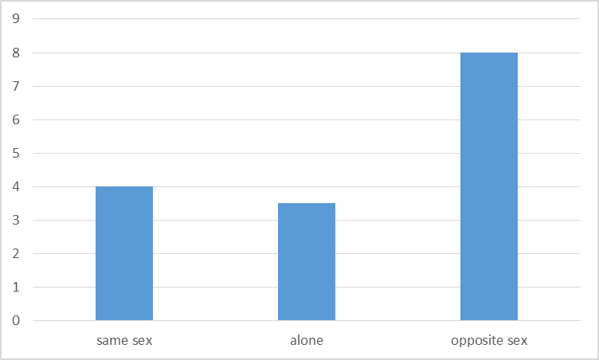
Figure 1 the femininity of product choice based on stimulus conditions

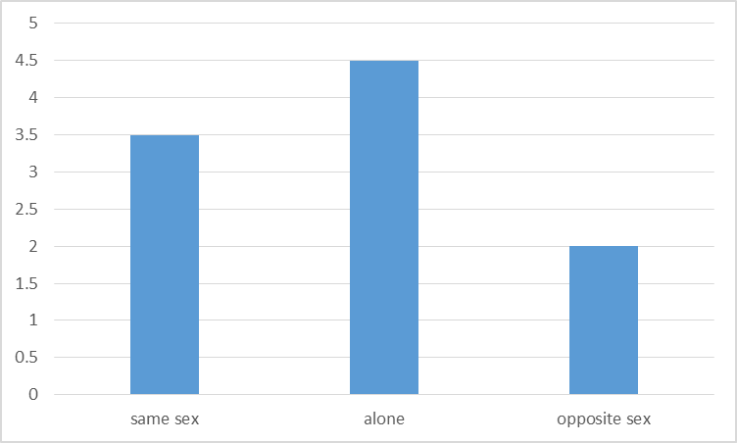
Figure 2 the distance the participants keep with the targets based on stimulus conditions
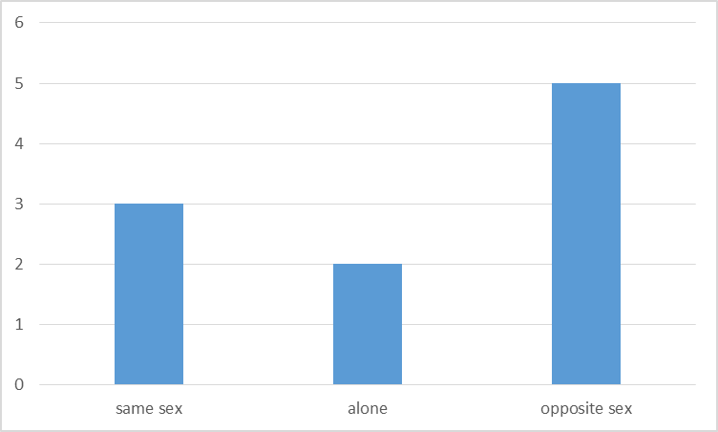
Figure 3 The willingness to have the targtes as the long-term mates based on stimulus conditions

- Discussion
Data support the hypotheses that women will use the social contextual information to help them judge the desirability of potential mates and they would find men more desirable when depicted with other women than depicted alone or with other men. Moreover in this study mating strategy and mating preferences are both taken into consideration and are both tested in a more implicit way, we hypothesized that women will take a more active strategy with the men depicted with other women than depicted alone or with other men. Therefore, we further hypothesized that women would like to keep a closer distance with the men who are depicted among women than depicted alone or among other men. Furthermore, women tend to dress more feminine when they are told to imagine attending a social gathering with the men depicted with other women.

Two potential alternative hypotheses were ruled out: (a) These differences resulting from target persons’ being depicted with others, in general or (b) these differences resulting from differences in the attractiveness of peripheral persons with whom targets were depicted. After we rule out these two hypotheses, men were still rated significantly more desirable to women when depicted with women than they were when depicted with men.

Furthermore this study adapts Hill and Buss’s paradigm. This paradigm, unlike the typical paradigm using the visa photos as the stimulus, uses the presence of same-sex others as the social contextual information. Therefore, this study is more relevant to daily life situations and thus could increase the ecological validity of the study. Besides, this study used different dependent variables to test the mating preferences and mating strategy. First, as there are studies showing that if women are interested in this potential mate, women tend to keep a closer distance with the potential mates. Therefore, the distance in which women feel at ease to talk with the target man can reveal their desirability of this target man. In this experiment, both part 1 and part 2 tested this hypothesis and the results show that in both parts the distance that women would like to keep with the men significantly varied between the men depicted alone and the men depicted with other women. Second, there are also studies showing that women tend to take a more active strategies such as dressing sexier or taking more weight loss pills to attract the men they are more interested in. In the pre-test of our experiment, the standard for us to choose the pictures of products is sexiness. We chose the top 25 sexiest products and top 25 most conservative products from Internet based on the ratings of two research assistants. When we first conducted the experiment, however, women did not choose the sexiest products as we predicted when they are told to imagine attending a social gathering with the men that they find most desirable. This may result from the differences in beauty standards between eastern and western culture. In western culture, being sexy is appealing and attractive. In the conservative eastern culture, however, being sexy may not have the same effects as it has in western culture. Therefore, we change the standard from sexiness to femininity as feminine clothes implicitly reveal the soft and sweet nature of women which is more acceptable and prevailing in eastern culture. After we make this change, the results support our hypothesis that women tend to wear more feminine clothes when they are told to imagine attending a social gathering with the men depicted with other women. This phenomenon can be explained in two ways: 1) Women find the men that depicted with other women more attractive thus they dress more feminine to impress them. 2) Women find there are many competitors thus dress more feminine to compete with them. Further studies can test which of the explanations are more plausible.

In sum, although there are many studies investigate the effects of social contextual information on mating preferences, the majority of these studies focused on the factors that will influence this effect. This study explores mating strategy. Moreover former studies on this effect mainly use the explicit rating systems to evaluate the desirability of the target person. This study mainly explores the implicit behavior to measure the desirability. This study operationalizes distance that the participants tend to keep with the targets as the dependent variable to indicate the preferences of participants and tests the participants’ mating strategy via their clothes choice By altering the measurement from an explicit rating system to an implicit behavior tests, this study indicates an new direction in the mate-choice copying field

- Limitations of the study
Although support was found for the research hypotheses proposed in this article, they should be interpreted with a degree of caution. For example, current studies relied on participants’ assumption that opposite-sex peripheral persons were romantically interested in targets. This assumption needs to be tested in future studies as participants could assume peripheral individuals to be relatives or friends of the targets.

- Conclusion
This research tested hypotheses about how the presence of same-sex others affects women’s desirability judgments of opposite-sex targets. This research supports a desirability enhancement effect that women should find men more desirable in the situation when men are surrounded with other women than the situation when they are alone or with other men. Instead of studying desirability in the explicit way by asking participants to rate it, this study explores desirability in an implicit behavioral way. This study operationalize the distance which the participants want to keep with the targets as the dependent variable to indicate the preferences of participants. This study also tests mating strategy, a dependent variable that has been overlooked in previous studies, by asking the participants to choose clothes when they are told to imagine attending the social gatherings with the potential mates.

References
Dugatkin, L. A. (1992). Sexual selection and imitation: females copy the mate choice of others. The American Naturalist, 139(6), 1384-1389.
Graziano, W. G., Jensen-Campbell, L. A., Shebilske, L. J., & Lundgren, S. R. (1993). Social influence, sex differences, and judgments of beauty: Putting the interpersonal back in interpersonal attraction. Journal of Personality and Social Psychology, 65(3), 522-531.
Hill, S. E., & Ryan, M. J. (2006). The role of model female quality in the mate choice copying behavior of sailfin mollies. Biology Letters, 2(2), 203-205.
Jones, B. C., DeBruine, L. M., Little, A. C., Burriss, R. P., & Feinberg, D. R. (2007). Social transmission of face preferences among humans. Proceedings of the Royal Society B: Biological Sciences, 274(1611), 899-903.
Schlupp, I., Marler, C., & Ryan, M. J. (1994). Benefit to male sailfin mollies of mating with heterospecific females. Science-AAAS-Weekly Paper Edition-including Guide to Scientific Information, 263(5145), 373-374.
Sigall, H., & Landy, D. (1973). Radiating beauty: Effects of having a physically attractive partner on person perception. Journal of Personality and Social Psychology, 28(2), 218.
Trivers, R. (1972). Parental investment and sexual selection.
Buss, D. M. (2003). The evolution of desire (rev. ed.).
Buss, D. M., Shackelford, T. K., Kirkpatrick, L. A., & Larsen, R. J. (2001). A half century of mate preferences: The cultural evolution of values. Journal of Marriage and Family, 63(2), 491-503.
Kenrick, D. T., Groth, G. E., Trost, M. R., & Sadalla, E. K. (1993). Integrating evolutionary and social exchange perspectives on relationships: Effects of gender, self-appraisal, and involvement level on mate selection criteria. Journal of Personality and Social Psychology, 64(6), 951.
Dugatkin, L. A. (1992). Sexual selection and imitation: females copy the mate choice of others. The American Naturalist, 139(6), 1384-1389.
Dugatkin, L. A. (2000). The Imitation Factor: Evolution Beyond the Ene. Simon and Schuster.
Dugatkin, L. A., & Godin, J. G. J. (1993). Female mate copying in the guppy {Poecilia reticulata): age-dependent effects. Behavioral Ecology, 4(4), 289-292.
White, D. J., & Galef Jr, B. G. (1999). Mate choice copying and conspecific cueing in Japanese quail, Coturnix coturnix japonica. Animal Behaviour,57(2), 465-473.
Eva, K. W., & Wood, T. J. (2006). Are all the taken men good? An indirect examination of mate-choice copying in humans. Canadian Medical Association Journal, 175(12), 1573-1574.
Hill, S. E., & Buss, D. M. (2008). The mere presence of opposite-sex others on judgments of sexual and romantic desirability: Opposite effects for men and women. Personality and Social Psychology Bulletin, 34(5), 635-647.
Jones, B. C., DeBruine, L. M., Little, A. C., Burriss, R. P., & Feinberg, D. R. (2007). Social transmission of face preferences among humans. Proceedings of the Royal Society B: Biological Sciences, 274(1611), 899-903.
Yorzinski, J. L., & Platt, M. L. (2010). Same-sex gaze attraction influences mate-choice copying in humans. PloS one, 5(2), e9115.
Little, A. C., Burriss, R. P., Jones, B. C., DeBruine, L. M., & Caldwell, C. A. (2008). Social influence in human face preference: men and women are influenced more for long-term than short-term attractiveness decisions. Evolution and Human Behavior, 29(2), 140-146. Waynforth, D. (2007). Mate choice copying in humans. Human Nature, 18(3), 264-271.
Uller, T., & Johansson, L. C. (2003). Human mate choice and the wedding ring effect. Human Nature, 14(3), 267-276.

Tversky, A., & Kahneman, D. (1975). Judgment under uncertainty: Heuristics and biases (pp. 141-162). Springer Netherlands.
Gigerenzer, G., & Todd, P. M. (1999). Fast and frugal heuristics: The adaptive toolbox.
Gigerenzer, G., & Todd, P. M. (1999). Simple heuristics that make us smart. Oxford University Press, USA. Hill, S. E., Rodeheffer, C. D., Griskevicius, V., Durante, K., & Edward White, A. (2012). Boosting beauty in an economic decline: Mating, spending, and the lipstick effect. Journal of personality and social psychology, 103(2), 275.
Hill, S. E., & Durante, K. M. (2011). Courtship, competition, and the pursuit of attractiveness: Mating goals facilitate health-related risk taking and strategic risk suppression in women. Personality and Social Psychology Bulletin, 37(3), 383-394.

