Disposition Effect and the Stability of Stock Price on SSE (Shanghai Stock Exchange)
Otto Han Fudan University

Abstract
This paper provides an in-depth analysis of an investor’s reluctance to realize losses and his willingness to realize gains——a behaviour known as the disposition effect——from a Chinese perspective. Statistics of the newly-issued stocks on Shanghai Stock Exchange (SSE) are analyzed, showing that Chinese investors share similar modes of behaviour as their foreign counterparts’. Moreover, large-cap stocks and small-cap stocks on SSE do witness different levels of investors’ disposition effect. The effect among buyers of the latter ones is more significant and contribute more to stock price stability.

This paper explores the disposition effect which may be able to explain why investors irrationally sustain loss or forgo profits on Chinese stock market. Quantitative analysis is presented to verify the impact of this effect on stock price stability, which may cast doubt on the classical assertion that human rationality dominates humans’ trading behaviour.

Empirical studies have illustrated that most investors have an illogical tendency; namely, to hold losers for a longer time than they would hold winners. For example, an investor tend to keep a loser at a loss of $3 and expect its boost, while he may probably sell the same piece of stock at a profit of $3 even when its price-increase seems sustainable. Edward(1977) named this irrational behaviour “disposition effect”.

In the past decade, many researchers have carried out the studies on disposition effect. For instance, Kato(1996) demonstrated disposition effect on oil futures markets, where it haunts both novices and experienced investors; Odean(1999) made an interesting argument that disposition effects enhanced market stability through a bargaining mechanism. Empirical studies concerning these propositions, however, have never been carried out on Chinese stock market yet.

The objective of this study, therefore, is to demonstrate the disposition effect on large-cap-stock and small-cap-stock transactions at SSE. It also discusses possible contributions of the effect to price stability at SSE. Moreover, quite a few psychological analyses have been performed to illustrate irrational behaviours, which this paper would review and summarize before analyzing the Chinese situation.

I. Literature Review
Previous research seem to support the hypothesis that winner-holders sell their stocks more readily than loser-holders. Motivations investors might have for doing so, however, remain contentious among researchers. Lakonishok (1986) once proposed that investors may value diversification of their portfolio more than mere profit when the stock price is boosted. Hence they would sell winners more quickly. Harris (1988) offers another explanation which stated that investors refrained from selling losers because the trading cost would comparatively be higher if they sold the “lower-priced” stocks. Shefrin (1995) also gave an explanation that investors would regret if they sold the winner at a price slipping from the peak. So with a natural tendency to avoid regret, they sold winners at a more acceptable price. In general, diverse propositions have been made on the origin of disposition effect.

Despite differences in these propositions, there is a general consensus among researchers that the disposition effect does exist on various markets. Studies by Ferris et.a1 (1988), Lang (1999) and Locke (2005) have all shown that disposition effect seems inevitable for most investors, which warrants my further investigation into this effect at SSE.

II. Data collection and Analysis
One feature of disposition effect on stock markets is the sudden surge of turnovers at a certain price, indicating that investors realize their profits on this level of price; and the turnovers for lower prices are significantly fewer, indicating that investors keep their losers, hope their prices will increase, thus, in Shefrin’s (1995) words, “avoiding regretting”. This obssession will last until their patience goes away with constant price decrease and most of them sell off the stocks.

This study explores whether investors sell their winners and losers at a particular price in large-cap-stock and small-cap-stock transactions, which illustrates the presence of disposition effect. To determine this “particular price”, I take the issue price as a reference. I obtain the data of turnovers and closing prices as well as other data needed from 2006-2007 Daily Stock File of SSE. The 120 stocks sampled in my studies are the new-issued shares through year 2006 and 2007. More specifically, I process the data of selected stocks between their 30th working day and the 130th. By casting out the data for the first 29 working days, I exclude the interference factors of noise-trading and speculation. Neither do I obtain the data for more than 130 working days since most previous studies have accepted the point that the issue prices’ impact on closing prices plummets after a duration of 135 days on average. (Shefrin, 1995)

I calculate the average daily turnover for each stock (denoted by av1). Each day I compare the closing price to the issue price, and categorize the turnover of that day into ten brackets, each featuring the number of closing price divided by the issue price (denoted by FD, ranging from 3.2 to 0.8). For each bracket of turnovers, I calculate its mean (av2) and get the deviation between av1 and av2 (DEV) following the formula below:
DEV=(av1/av2)-1
DEV indicates the difference between the turnover and and average turnover for a certain range of price. The higher value of DEV is, the more turnovers the piece of stock has for the range of price in the corresponding bracket.

Therefore, we may present the list of DEV figures for ten figures, and it is clear to see how the turnovers are related to the FD figures. For every peice of stock, we can find a certain FD figure that corresponds with a particular boost in turnovers, which implies the price where most sale of stocks arises. 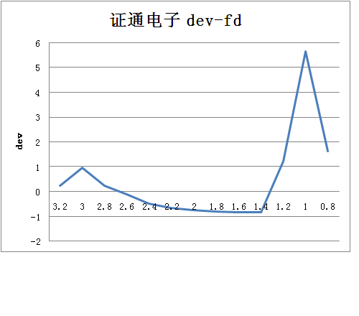
After repeating this process for every piece of the sampled stock, I gained the aggregate figures for the sets of large-cap-stock and small-cap-stock as demonstrated by the graphs below respectively.
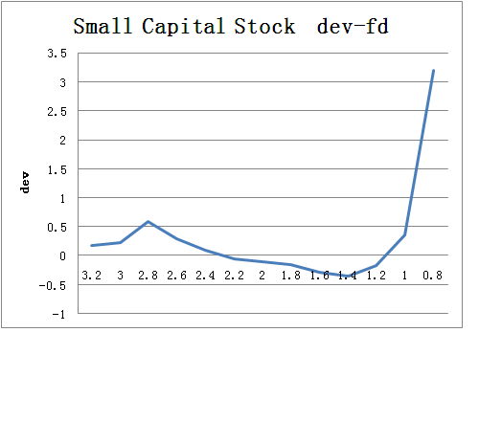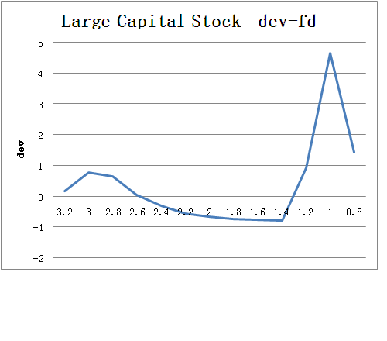
Figure two
Figure one

Table 1 demonstrates the DEV figure of the ten brackets for large-cap-stock and small-cap-stock. The first colummn presents the FD value for ten brackets, the second presents DEV figure for small-cap-stocks, the third shows the DEV figure for large-cap-stocks. Figure one and figure two chart the value of DEV for each bracket. It could be observed from the figures that for the 100 days I have observed, more stocks are sold at a price 2.8-3 times of their issue prices, while fewer stocks are sold at a price 1.4-2.8 times of the issue prices. Large-cap-stock DEV value boosts around the FD value of 1, indicating that large-cap-stocks are largely sold off at around their issue prices, while small-cap-stocks are sold off at a price lower than their issue prices as shown in figure two.

For small-cap-stocks, the range of price between 2.4 and 1.8 times of the issue price witnesses fewer turnovers, which suggests the promotion of stock price stability around these prices. However, DEV value for large-cap-stocks never stays around zero for a relatively long time, which implies that disposition effect contributes less to their price stability. One supportive evidence for this deduction is the fact that large-cap-stock turnovers fluctuate more strongly than those of the small-cap-stocks.

III. Discussion
With a sample of 120 newly-issued stocks through 2006-2007, this paper analyzes stock sales on SSE, and finds that most investors sell their stocks at a particular range of price. This range of price could be 2.8 or 0.8 times of the issue prices for small-cap-stocks, and 3 times of the issue prices or around the issue prices for large-cap-stocks. Between the two boosts of turnover surges as shown in the graoh, there is a wide range of prices with depressed transaction for both two types of stocks. This well illustrates that Chinese investors sell winners more quickly than they sell losers, which indicates that the disposition effect on SSE works similarly as what Ferris (1998), Lang (1999) and Locke (2005) have discovered in the stock markets of other nations. Moreover, the wide range of depressed transaction stabilizes stock prices, which corresponds with the results of Odean’s (1999) research.

Another finding of this paper is the divergence between large-cap-stock shareholders and small-cap-stock shareholders, which previous research seldom discusses. Disposition effect among the latter ones is more significant and contribute more to stock price stability. In the macro scenario, however, both of them make similar irrational investment decisions.

IV. Conclusion
Using a relatively small dataset, this paper examines the presence of disposition effect among Chinese investors on SSE. Unlike prior studies in this field, this paper discusses the effect among large-cap-stock shareholders and small-cap-stock shareholders separately, and displays several features implying that disposition effect for small-cap-stocks seems more intense. Deductive reasoning has been made to illustrate that disposition effect could contribute to stock price stability, while disposition effect for small-cap-stocks seems to stabilize their prices more significantly.

Findings in this paper suggest an establishment of a supervisory system that observes, monitors and controls disposition effect on SSE. Since the regularity of stock prices and turnovers may prompt arbitrageurs to make profit by speculating on small-cap-stocks, the supervisory system should prevent them from manipulating stock trading and protect common shareholders.

If more cademic effort is directed to interpreting how the disposition effect poses impacts on SSE in future studies, a deeper understanding of Chinese shareholders’ irrational decisions will be in prospect. It is also necessary to clarify the mechanism through which the disposition effect pervades and deepens among Chinese investors of different characters, hopefully within the frame established by Lakonishok (1986) and Harris (1988). Further research may also focus on the different modes of disposition effect large-cap-stock shareholders and small-cap-stock shareholders demonstrate. In this process, case studies can be more effective in engendering in-depth and meaningful understanding than time-series econometric analysis.

In this sudy, large-cap-stock refers to the piece of stock having more than 2.5 billion tradable shares, and the rest is classified as small-cap-stock.

