Does female employment status influences marital stability directly?

Abstract
This paper analyzed time series data of the United States from 1995 to 2008 to explore the influence of female employment status on marital stability and whether the influence is direct. In a dynamic linear regressive model, women’s employment and adjusted divorce rate have negative correlation, but the influence is not direct. The increase of divorce rate mainly resulted from women’s higher education level and men’s unemployment rather than women’s paid work. Good language!
Introduction
Female labor force participation has experienced an extraordinary increase in the last decade, while the divorce rate rose dramatically in the same period where?. According to the United Nations Statistics Division, women’s economic activity rate on global level has been over 80% since the twenty-first century. Women’s share of the adult labor force now approaches 50% in most developed and almost all developing countries (International Labor Office, 2005). Furthermore, women’s wages in manufacturing as a percentage of men's wages reached 85% in North America and approximately 70% in Asia (Yearbook of Labor Statistics, 2003), which implies a significant reduction of wages gap between husbands and wives. On the other hand, adjusted divorce rate doubled in the last ten years (Demographic Yearbook, 2000 and 2010), which reflects the current situation on marital stability.
With the elevation of female employment status, the role difference between male and female gender becomes much less, which is consistent with Becker’s theory of marriage (1981) that the specialization on domestic work and market work maximizes the utility for each of the two spouses. There are two basic types of specialization: the traditional “housewife, working husband” and the opposite “house husband, working wife”. In principle, there should be no difference between the two types in marital stability and satisfaction according to Becker’s theory, but a number of previous studies indicate a substantially higher risk of divorce when the wife and husband specialize in business and household work respectively.
Now the inverse correlation between female employment status and marital stability has been accepted as a prevalent hypothesis in research on family, but the question how women’s paid employment harms the marriage is far from clear. Some researchers believe that a woman in paid work, especially a well-paid one, tends to be hypercritical about her husband and more likely to be irritated by household chores, resulting the breakdown of a marriage. While another group of people regard the increase of divorce rate as the result of husbands’ actions rather than wives’ when women get higher employment status. A study supporting this view concluded that men are more likely to cheat when they are economically dependent on their female partners (Munsch, 2010).
In terms of social environment, the traditional notion of men as breadwinners still remains, partly because on average men still earn more than women. Pressure from social expectations and self-esteem make it more likely for men to flee from the marriage, especially in a period of economic depression.
The object of this paper is hence to explore the influence female employment status has on marital stability and whether the influence is direct or not. First, research and viewpoints in recent years are reviewed against the present social and economic background. Then relevant data on a state level in the United States is tested with an econometric method by a linear aggressive model to contribute to the comprehensive interpretation of the question.
Literature Review
Attention has been paid to the relationship between women’s employment and marital satisfaction since 1960s. Nevertheless, the approaches applied in early research (see reviews in Hoffman and Nye, 1974) were overly simple, most presented by a bivariate model, resulting considerable discrepancy in conclusions. Therefore, this paper will focus on research in the latest twenty years that are more scientific in methodology and more convincing in results.
Some studies find a negative correlation between women’s employment and marriage stability, that is, women’s status in market work is usually represented by wage income which is easy to measure and collect. A study using German panel data from 1984 to 2007 found that if the wife works and earns more than 40% of her husband, marital stability is significantly altered compared to a traditional housewife (Kraft and Neimann, 2009). A piece of research conducted in China reached a similar conclusion: when the income ratio of husband and wife in a family is lower than two, the risk of divorce increases rapidly (Shi Lin and Zhang Jinfeng, 2002). A generally accepted explanation is that those women independent in finance tend to have more requirements from the other and do not have to endure dissatisfaction in marriage since they have comparatively higher bargaining power in family life.
Another explanation focuses on the division of domestic work and paid work, under the assumption that a woman’s employment decreases her share in housework. In general, gender differences exist in the sensitivity towards inside and outside work. Women seem to be more sensitive to division of domestic work and do not threaten the marriage by working outside; the dissolution of marriage mostly comes from men’s decision (Sayers, 2011). Such result implies that women’s concern for the family, therefore the incentive to initiate a divorce, is not greatly influenced by their employment status. Another study also supporting this conclusion shows that women’s employment does not destabilize happy marriages on the individual level but only provides financial security of distribution in unhappy marriages (Schoen, Astone, Rothert, Standish and Kim, 2011).
These studies offer several explanations all of which suggest a negative relationship between women’s employment and marital stability. However, some other studies tell a completely different story. Research from Schwartz (1994) concluded that dual-employment spouses where women participate in providing the family and men help in housework tend to express deeper understanding of the partner’s pressure. This kind of empathy is stability-enhancing, because it generates a sense of family responsibility.
跟上文衔接？Most empirical studies use sample data collected by telephone or face-to-face interview. At individual level, the degree of marital satisfaction cannot be directly demonstrated. The conventional method is using substituted variables replacing the immeasurable explanatory variables with some measurable ones, such as the number of quarrels in a specific period, sexual life or the score of a well-designed questionnaire. Therefore, the results are geographically restricted and inevitably contain personal feelings. Moreover sample analysis cannot distinguish the influence of macroeconomy. The great recession has significant impact on employment rate, which forces women to enter the labor market (Amato and Beattie, 2011). In fact, economic downturn can influence family relation in opposite ways. It may cause conflicts in a family, but it may also unite the spouse more closely through the hard times.
New social expectations plays a role in the decision of divorce, too. General notion towards roles in gender is changing gradually from traditional “market husband and housewife”, but the contemporary trend presents social ambivalence. For women, they are encouraged and admired to enter labor force market; on the other hand, high personal income and heavy burden for family provision do not release women from domestic responsibility (Brines, 1994). For men, the requirements to contribute more to child care and domestic chores do not diminish the expectations for them to become breadwinners (Potuchek, 1992). Such notion imposes double burden on both husband and wife, making/rendering conjugal relation more troublesome and unstable. Since the changing of social expectation is a long-term process, it can be regarded as an exogenous factor in the time period of a decade.
Methods
This study uses data in state level in the United States from 1995 to 2008. There are two primary advantages of the data used here. Firstly, the completeness and availability of numerous control variables increase significantly in the latest decade. Secondly, statistical approaches have been developed with the improvement of research technique and specific tools. Data on female employment is taken from the Bureau of Labor Statistics (BLS), described by two variables: women’s labor force participation rate (emprat) and female labor force bargaining power in family (labpow). The second variable is represented by the proportion of nontraditional family pattern where wife is the only one in labor. More specifically:
Ignoring some interrelated variables, such as education level, unemployment rate by sex and macroeconomic growth can result in serious systematic error as a kind of endogenous problem. Spouses with higher education levels (eduhig) are expected to be more rational in their attitudes towards marriage but may have stronger requirements from the partner. High unemployment rate, especially the unemployment of married men (uemrat) can affect the labor division in market. GDP adjusted for inflation (gdp) reflects the real income of the whole nation that can influence people’s actions in work as well as in life. Therefore, these three variables are added to the liner model in order to distinguish the direct influence of women’s employment on marital stability. Information about these variables is available in the Statistics Abstract/summary? of the United States (2009 and 2010).
Most previous models estimate the divorce rate in t period with employment rates in t-1 period (emprat (t-1)) under the assumption that people make some choice on marriage according to the employment status of the previous year. For most people now, however, initiating a divorce is not usually an easy decision which can go through a relatively long period than a year, therefore cannot be represented appropriately by only one logged variable in female employment. Furthermore, the consideration of divorce may have a backwash effect on working behavior, usually as a kind of disturbance, and then change the employment status of the women who has a greater chance to separate from her spouse in the near future. Such feedback effect violates the assumption of strictly exogenous explanatory variables. Adding a two-year-lagged variable (emprat (t-2)) is helpful in solving these problems.
The same problems do not exist in the handling of education level and female labor force status in family that are not significantly affected by other variables. Since the economy situation measured by GDP has an instant effect on the employment rate, lagged variable is not necessary either. In account of such facts, the model used in this paper include female labor force participation at t-1 and t-2 period, and only draws on current variables to describe the other factors mentioned above.
The formula for the analysis is as follows：

For the sake of clarity, the definitions of variable names are listed below once again：
divrat | = | adjusted divorce rate
emprat | = | employment rate of women (women’s labor participation)
labpow | = | female labor force bargaining power in family (the ratio of only-wife-in-labor pattern to the total number of married couples)
uemrat | = | unemployment rate of men
eduhig | = | the proportion of high-educated woman(above high school level)
gdp | = | real gross domestic production adjusted for inflation (2000 as the base year)
e | = | error term (with a mean value of zero)
β0 | = | intercept values
βi | = | slope parameters where i = 1, 2, 3, 4, 5, 6, 7.

Data and Results
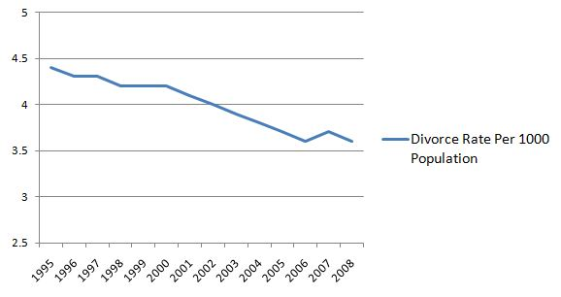Figure 1 shows reported divorce rates in the United States from 1995 to 2008, which is defined as the number of people who have experienced divorces per 1000 population.

Fig.1 Divorce rate per 1000 population from 1995 to 2008
The statistical divorce rates decreased progressively in this period according to the Bureau of Labor Statistics. Such situation mainly results from the decreasing marriage rates in the same period, which experienced a significant drop by 21%. Nowadays people have less incentive to start a family, because the economic recession in western countries, especially in the United States induces higher cost and higher risk of marriages. In addition, more and more open-minded pairs choose cohabitation and do not value an official certification. To explore the relationship between female employment and marital satisfaction, data on divorce rate, the variable that measures marital satisfaction, was adjusted to eliminate the indirect effect caused by changing marriage rate.
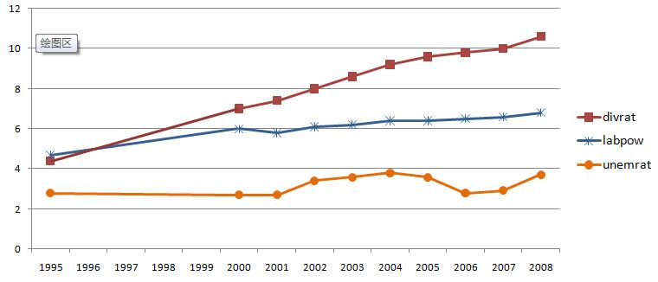Figure 2 shows adjusted divorced rate, female labor force bargaining power in family and unemployment rate of married men.
Fig.2 Adjusted divorce rate, female labor force bargaining power in family and unemployment rate of married men from 1995 to 2008
The unemployment rate of married men (uemrat) is defined as the number of the unemployed per 1000 married men. According to BLS, the rate declined only in 2005 and 2006, followed by a substantial increase afterward. Such trend is consistent with the claim by the National Bureau of Economic Research (NBER), that the United States has entered a new round of recession from December of 2007, before which the economic environment showed a slight improvement. Comparatively speaking, the fluctuation of uemrat is not significantly obvious, mainly because men without a job are less likely to get married, therefore not included in the statistics.
Figure 3 puts?? divrat and the proportion of high-educated women in marriage. From the figure, these two variables have consentaneous trend, of which the eduhig increases faster, doubled in ten years.

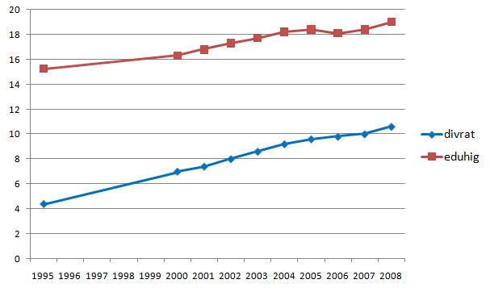

Fig.3 Adjusted divorce rate and proportion of high-educated women employed
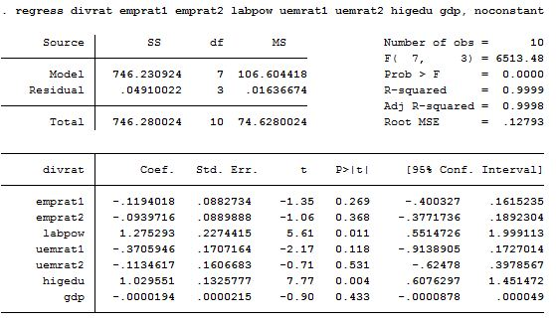Table 1 shows the results of the dynamic linear regression model given above.
Tab.1 Results of linear regression with constant term.
The original formula:

The estimated regressive function:
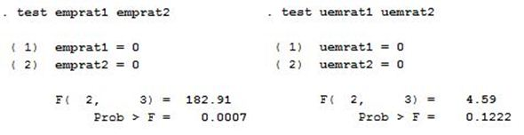As emprat2 is one year lagged of emprat1, the existence of multicollinearity makes it difficult to separate the effect of the two variables that are linearly correlated to a large extent, which means the deviation of the estimated coefficients from true values of the two variables may be considerable. However, this is not a serious problem here. The separated coefficients of the two variables are not particularly important, since they both measure the influence of female labor force participation on marital stability. What should be concerned is the joint influence resulting from the two variables. Whether the joint influence is significant or not can be tested in the method named after Ronald A. Fisher (F-Test). The same process is applied to uemrat1 and uemrat2. The results of the tests show in Table 2.
Tab.2 Results of F-Tests in (emprat1, emprat2) and (uemrat1, uemrat2)
Discussion
The coefficients of emprat1 and emprat2 reveal a negative relationship between female labor force participation and marital stability, which is contrary to common understandings and is not consistent with the reality that emprat and divrat both increase during the period being studied. Indeed, as is shown in Table 2, the combined effect of the two variables is not significant with a quite low P value of 0.0007. Therefore, the negative coefficients may result from inaccuracy in measurement then should not be taken into account. The same result came out in a study by Sayers (2011), who said women do not threaten the stability of the marriage by taking a job since they are more sensitive to domestic work. Due to the low degree of significance, gdp is not considered in the analysis, either.
The value of indicates that a one point growth in the proportion of only-wife-in-labor pattern is expected to bring about a 1.2 point increase in real divorce rate, while female participation in labor force is not significant by the preceding analysis. Such a result provides support to the research conducted by Kraft and Neimann (2009), in which they concluded that the relative employment status and income is one of the main contributing factors in the breakdown of a marriage. In an only-wife-in-labor family, the wife has comparatively large or complete bargaining power, which allows women to be more fastidious about the husband and provides women with finance security when the marriage finally collapses.
By?? the second F-Test in Table2, the correlation of male unemployment and divorce rate is significantly negative. During periods of high unemployment of married men, the standard of living is lower and the cost of initiating a divorce is higher (Amato and Beattie, 2011), thus couples tend to make concerted efforts in times of trouble. According to the regressive function, when the male unemployment increases by one percent, the long-run effect on adjusted divorce rate is an increase by nearly half percent.
衔接！Education level has a positive correlation with adjusted divorce rate. The T value of is the highest one in the regression, consistent with the tendency in Figure 3. Generally spearking/in general, high-educated women acknowledge deeper understanding of family and have higher responsibility to maintain a relationship with her partner, but such a tendency may be not as remarkable as the change in women’s expectations of a marriage and requirements of men. Women’s high education is also a security in single life since it is related to high wage income.
The purpose/objective of this paper is to investigate the influence of female employment status on marital stability, and whether the influence appears in direct ways or indirect ways. The results clearly support the common understanding that women’s employment and marital stability have a negative correlation, but the increase in female employment status does not seem to directly affect the marriage. The growth in women’s labor force participation is a consequence of the increasing unemployment rate of married men to a considerable extent, and the influence indeed comes from men’s status and choice. Moreover, higher wage income accompanied higher education level, while women’s attitude towards marriage is mostly affected by education rather than by economic factors.
Since of the current study analyzed relevant data in the United States, the findings and conclusions can apply to the most developed countries but cannot give reasonable interpretation to the status quo in developing countries, where macroeconomic situation and social norm can be widely different. Research in developing countries will contribute to a more complete explanation of the question.

The divorce rate here is adjusted by marriage rate.
The study was presented at an annual meeting of the American Sociological Association (ASA), 2010.
Corresponding variable name is given in italics in the brackets after the variable.
National economic growth is usually represented by the yearly Gross Domestic Product (GDP).
In state level, one period usually refers to one year.
This term, lagged variable, belongs to the statistical analysis of time series data, where the dependent or induced variable is predicted based on its past values, for example, measured at the same time but one year earlier.
Multicollinearity is a statistical phenomenon in which two or more predictor variables in a multiple regression model are highly correlated.
In this case, if emprat1 and emprat2 are not jointly significant, we can conclude that employment rate of women has little effect on marital stability without necessarily distinguishing the separate effect of the two variables.
Decided by the low T value of variable gdp (|t|=0.90) and the coefficient value (close to zero).
Long-run propensity is defined by, measuring the effect on the dependent variable in the long term if unemployment of men increases by one point in one certain period and does not fall back afterward forever. The value of long-run propensity of uemrat is -0.4840557.

