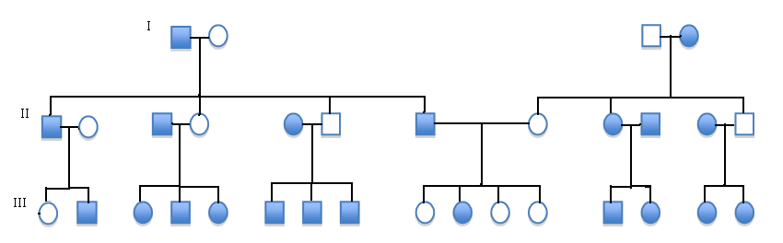
Karina Febriani Hudono
10301016061

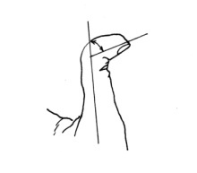
Pedigrees

Trait:

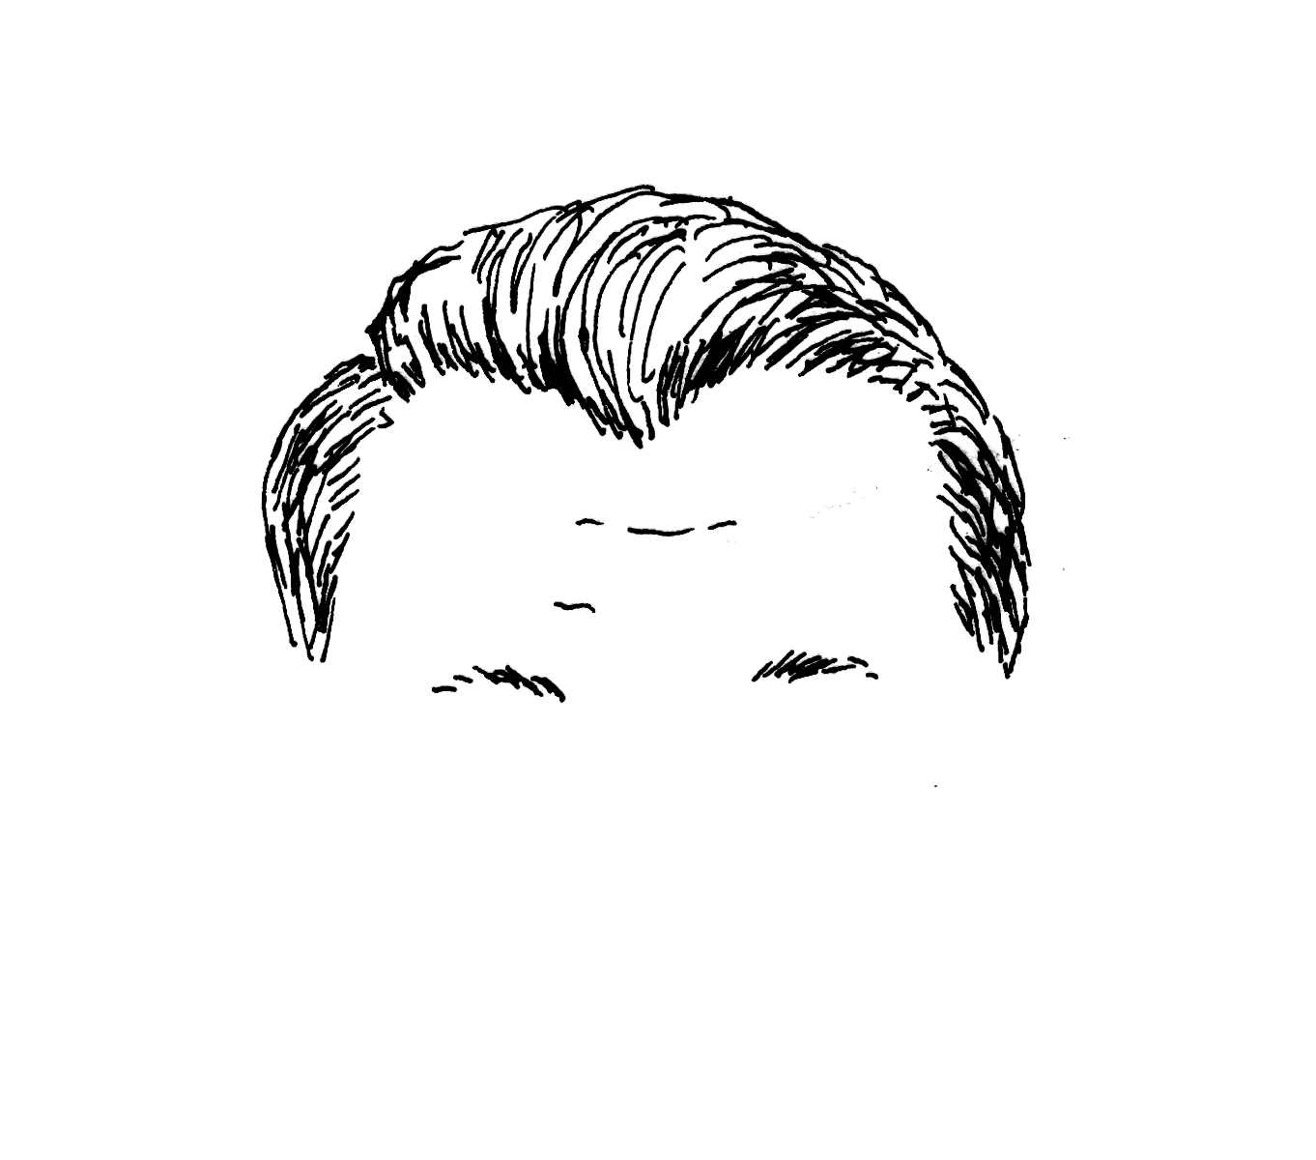
Trait:

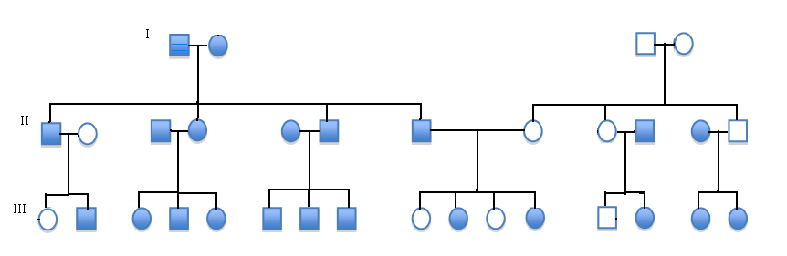

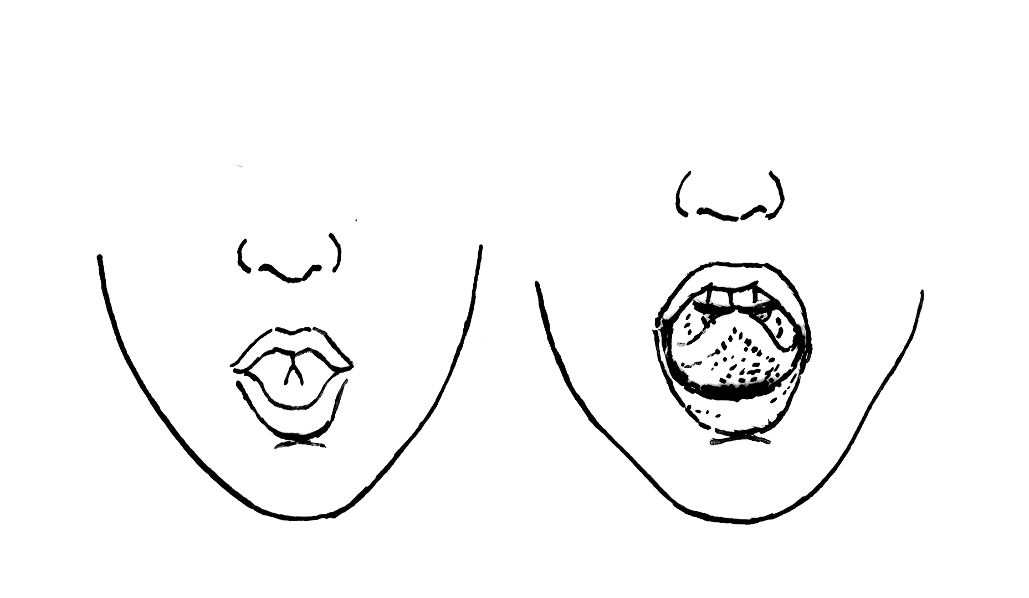
Trait:

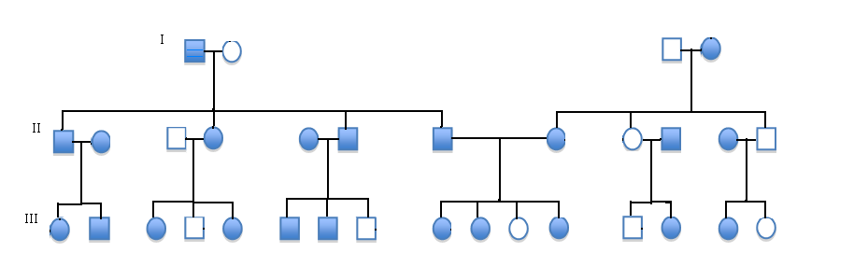

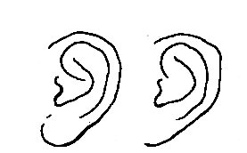
Trait:

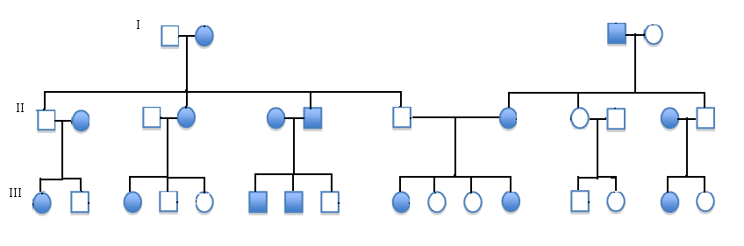

Legend:

: woman with the trait
: man with the trait
: woman without the trait
: man without the trait
I : first generation
II : second generation
III : third generation

